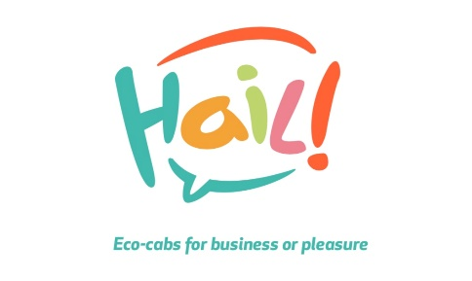
Hailservices and Ibis join forces

FOR IMMEDIATE RELEASE: 10 May 2021

Hailservices granted use of iconic cycle works
Hailservices to operate from Swift Cycle Works

Coventry, West Midlands: Hailservices today announced a new partnership with Ibis Hotels to allow the use & regeneration of the Swift Cycle Works, an iconic building in the cycling industry of Coventry. Believed to be the last surviving site where James Starley was based, it represents a new chapter in basing a zero carbon company here. This partnership will see Hailservices operating from the site as a micro hub to support our Inner City Taxi, delivery, and tourist services

Keith Higham, Director of Hailservices, commented: “This represents real intent for the city to welcome emission free vehicles to combat congestion & pollution & we would like to thank IBIS Coventry for having the foresight and trust in allowing us to work from the Swift Cycle Works and the Coventry BID team who we were able to reach out to in helping us find this solution through their partnership with the City Centre business community.

Jade Jones, Sales Manager, ibis Coventry Centre: “We are delighted to see our Swift Cycle Works being regenerated for the use of Hailservices for this exciting new, ecofriendly business in time for the City of Culture 2021. The partnership supports Accor’s Planet 21 sustainable development program priorities to innovate with partners and work with local communities and we are looking forward to a successful future for Hailservices and ibis Coventry Centre.”

Trish Willetts, Director at Coventry BID, commented: “It was great to hear that the connection between Hailservices and the Ibis team had been facilitated with the help of one of our BID Bites newsletters – especially as something so exciting has come out of it! We are incredibly proud of all our businesses and always keen to support in any way that we can. Hailservices is an important element of our great city’s toolbox of recovery and we can’t wait to see where their success takes them next!”

The benefits of this new partnership include.

- Central location in line with our last mile operating policy
- Increased awareness of both brands and their mutual objectives
- Regeneration of an iconic building in time for The City of Culture 2021

ibis Coventry Centre is a vibrant, newly refurbished 90 bedroom hotel located centrally on Mile Lane, Coventry. The hotel is within walking distance to the main business and leisure areas of the city, as well as Coventry train station. The hotel is Accor ALLSAFE approved and offers onsite car parking for hotel guests, local businesses and visitors to the city along with Fogg’s restaurant open for breakfast, lunch and dinner in line with current restrictions.

Editor’s Notes:

About Hailservices

Hailservices was started in 2020 to offer zero emission Taxi and delivery services in Coventry using Pedicabs as a means of transport.

Our core principles are in-line with the UN Sustainable Development Goals & the UK Government’s objectives
for cleaner air and a carbon neutral future (net zero).

With a vision of every City and Town in the UK adopting a green delivery system, Hail are positioned to introduce a customer focused, on demand service which reduces inner city pollution, congestion, and road damage.

By working to Last mile principles, Hailservices brings together supply chain & transport planning to deliver people and goods from a hub on the outskirts of the city centre, right into the heart of the city, allowing efficient, clean and green operations.

Services offered are varied and fall under the categories:

- Private Hire Taxi
- Delivery
- Hospitality & Tourism
These were identified by the business as key drivers of change by
- Offering to grocers and retailers an environmentally and financially sustainable alternative to fossil-fuelled vehicles when making B2C deliveries in high-density urban areas.
- Reducing inner city pollution levels by reducing the number of fossil-fuelled vehicles on the road.
- Increasing society’s awareness of the environmental and social issues we all face, and to inspire the communities within which our hubs operate to contribute to solutions that address these issues.

Website: www.hailservices.co.uk
Facebook: hailservices1
Twitter: Hailservices
Instagram: Hailservices1

